Georgia State Parks and Historic Sites
Weekend Summary
07.27.2020

Crowds:
- Overall, less day use crowds than in past weeks with some sites reporting being busier in the mornings and slower visitation during the hot afternoon temperatures. Sites that had to temporarily limit day use access due to capacity include: Cloudland Canyon, Vogel, and Red Top Mountain. Fort McAllister, Fort King George, and Wormsloe continue to have capacity issues with large family groups and restricting access in Visitor Centers/Museums.

- Golf Course activity was 36% over last year this past week. The Sylvania Visitor Center reported over 150 vehicles on Saturday. Boat ramps continue to be busy but slower than previous weekends. Fort McAllister, Red Top and Florence Marina had the most boating activity over the weekend. LED assisted Crooked River with a jet ski left tied to the dock for over six hours. The lake at Laura Walker was extremely busy with one boating accident with injuries that is still being investigated by LED. Beaches were busy across the state.

Staffing issues:
- As of today, the Division has 25 part-time and full-time staff out due to COVID-19 related reasons. A total of 59 employees have tested for COVID-19 and 7 were positive, 43 negative and 9 are awaiting results. Staff at four sites are returning to work after being out due to COVID-19 related issues.
- As of today, a total of 47 Camp Host Units (approximately 94 people) have left due to COVID-19 and 41 units have been replaced. This turnover is only COVID-19 related and does not include generalized host cancellations.
- Fort Yargo, Red Top, and F.D. Roosevelt are struggling to fill housekeeping positions. Other staff and nearby sites have assisted with turning cottages. Some sites are struggling to fill and retain host positions.
Positives
- Fort King George Manager Valarie Ikhwan was on WTOC Morning Break, Savannah to promote the site as a good place to get outdoors.
- Dirty Spokes held a successful race at Red Top with 250 runners on Saturday following social distancing practices and with staggered start times.
- The second phase of the campsite renovation project at Fort McAllister has started.
- Website Statistics continue to increase. This past weekend total pageviews were up 57%. Reservation pageviews were up 44% and the Alerts Page received 10,945 pageviews.

Challenges
- The U.S. coin shortage has been a challenge in some sites.
- High Falls assisted local EMS with rescuing an injured hiker.
- A cottage guest at Vogel that had checked out Sunday, notified the park on Monday that they tested positive for COVID-19. Staff had cleaned the cottage and another guest had checked in to the cottage. The new guest was provided the information including the site follows the CDC cleaning guidance, as well as an option to move to another cottage or receive a refund. The guest chose to leave and receive a refund.
- Chattahoochee Bend staff cleaned up racial graffiti at the tower and photos were sent to LED for follow-up.
- Elijah Clark called for assistance from the local Sherriff’s Office to respond to noise issues with a group playing loud music.

Financial Update

Past Weekend:
Overall occupancy for all reservables increased 6% this past weekend to 72%. Camping increased 11% reaching 83% occupancy. Cottage rentals declined by 2% and yurt rentals by 3% compared to last year.

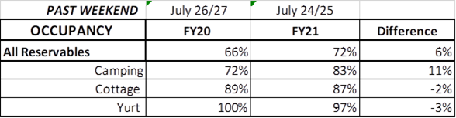

Upcoming Weekend:
For the upcoming weekend, there is a 5% increase in all reservables at 64% occupancy. Camping is showing a 7% increase, yurts are looking to improve by 3%, while cottage occupancy is currently the same as last year at 85%.

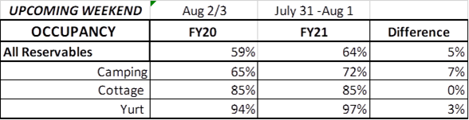

Revenue:
Since COVID began in March through July 19th, park revenues have increased 7% or $1.3 Million over the previous year, same time period. For FY21, YTD through July 19th, park receipts have decreased 2% or $59,000, although this past week is the 1st week in July that we have seen an increase in our revenue, as our revenue improved 8% this past week.

For overnight accommodations – camping revenue continues to significantly increase. This past week camping revenue improved 26% or $57,000. Cottage revenue also saw an improvement, increasing 10% or $22,000. Yurts improved 1%.

Historic site admissions did decline in comparison to last year, but only by 4% or $2,000.

Golf saw a 36% or $13,000 increase for the week.

For July 20th -26th, ParkPass revenue increased 31% or $34,000 compared to last year.

